**ASSIGNMENT NO-9**

**Aim**: Implement Map reduces operation with suitable example using MongoDB.

**Objective**: To understand and implement map reduce

**Input**:

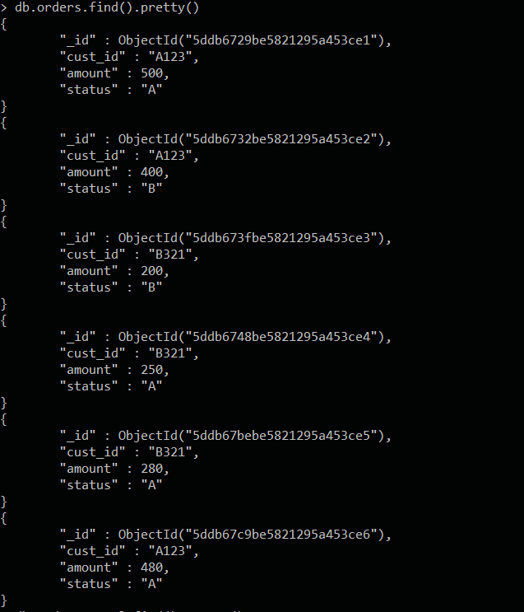

**Implementing map reduce**:

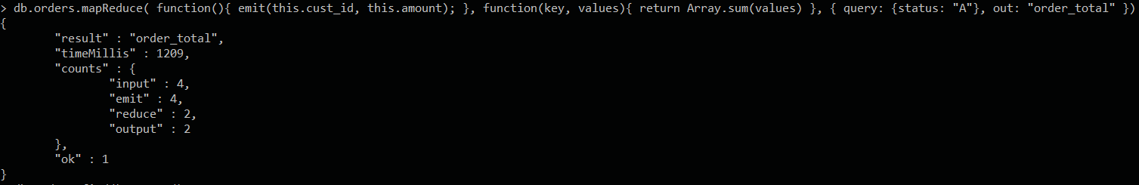

**Output**:

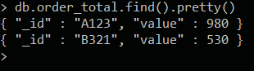

**Conclusion :**

Successfully implemented map reduce on an example schema using MongoDB.